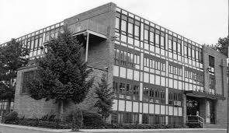 |  |  |  | Saint Michael School  27 Crittenden Street  Newark, NJ 07104  Phone: 973-482-7400  Fax: 973-482-1833  www.smsnwk.org  “We’re Talking Proudly”
The student(s) listed below has/have enrolled in St. Michael School for the year ___________________.

Student’s Last Name | Student’s First Name | Date of Birth | Entering  Grade |  | Name of School  Phone Number  child attended last year | Address  City/State

I hereby authorize the sending of all school records regarding my child to St. Michael’s School.

Date: _____________________ Parent Signature: ______________________________

Please forward all Academic Records, Test Scores and *Original Health Records/A45 and any other pertinent information to:

St. Michael School Attn: School Secretary
Attn: School Secretary OR Fax to: 973-482-1833
27 Crittenden Street
Newark, NJ 07104

___________________________________________________________________________________________________________________________________
*According to the “New Jersey Guidelines for School Health Services” (Pg. 71) the original A-45 health record of each student must follow that student when he/she transfers to another school. Therefore, we are requesting the health records of the above student(s), who are presently enrolled in our school.

