School Blazers and School Shoes are required for grades 5, 6, 7, 8

Wheeled Bookbags are allowed, but they must fit in lockers.

REQUIRED FOR ALL GRADES - (EXCEPT AS NOTED)

Grades K-3  NOTEBOOKS  *REQUIRED PURCHASE IN SCHOOL | # REQUIRED | PRICE
Kindergarten  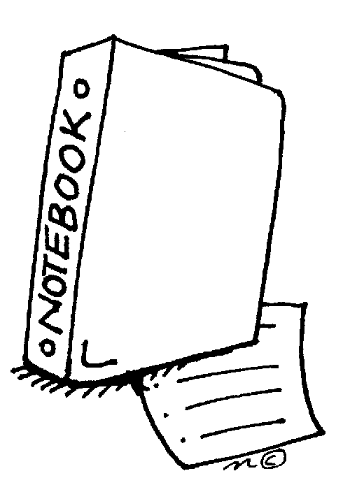  1st Grade  2nd Grade  3rd Grade | 6  8  11  11 | $2.25/each  $2.25/each  $2.25/each  $2.25/each

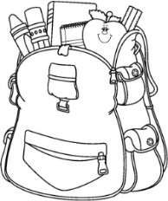

From October - May
orders are filled on FRIDAYS only
from 8:00 - 8:45 a.m.
Grades 4-8  NOTEBOOKS  COMPOSITION NOTEBOOK | # REQUIRED | PRICE
4th-6th Grade  7th-8th Grade | 12  12 | $2.25/each  $2.25/each
EXACT CHANGE REQUIRED
AS NO CHANGE WILL BE GIVEN

IN SCHOOL PURCHASES  (IF YOU CHOOSE) | PRICE
- Pencils  - Pens  - Paper Book Covers  - Folders  - Pencil Cases: Small  Large  - Ruler - 6 inch (1st Grade)  - Ruler (Grades 2-8)  - Compasses (Grades 5-8)  - Protractors (Grades 5-8)  - Theme Tablets | .25  .50  .50  $1.60  $2.00  $3.00  $1.60  $2.10  $1.85  $1.85  $3.00

Homework Pad & Nicky Folder  *REQUIRED PURCHASE IN SCHOOL | PRICE
Grades 3-5 Green Homework Pads | $6.00
Grades 6-8 Burgundy Homework Pads | $6.00
Grades 3-8 Nicky Folder | $6.00

Gym Suits & Ties  *REQUIRED PURCHASE IN SCHOOL | PRICE
Gym Set | $30.00
Gym Shorts | $15.00
Gym Shirts | $15.00
Grades 4-8 Ties | $13.00

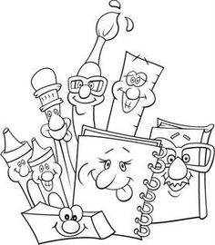

PURCHASED OUTSIDE OF SCHOOL:

- Glue/Glue Sticks
- Crayons (at least 24)
- Bookbag (We have small SMS ones at $22.00)
- Grade 3-8 Pocket Dictionary
- Grade 3-8 Thesaurus
- Scotch Tape

PLEASE NOTE:
- KINDERGARTEN - Change of clothes -change each time clothes are soiled. Please bring first day of school in a plastic bag with child’s name on it.
- No binders due to limited desk space. Use folders for loose-leaf or use theme tablets.
- White out is not allowed.
- Books not covered will not be allowed to be taken home. If student does not have a waterproof bag-books stay in room.
- ALL CHILDREN ARE REQUIRED TO HAVE 4 SHARPENED PENCILS DAILY.

Classroom teachers will distribute a “class supply required list” in addition to the “School Required List”

